**Lecture: Running Ansible Commands**

Not everything has to live in a playbook. We can do some pretty cool things with a single command right at the command line.

Its diff from playbook

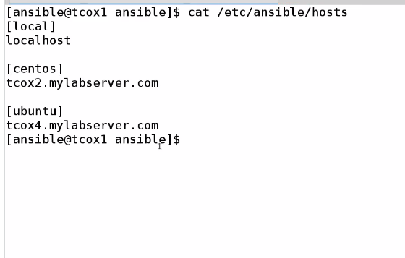

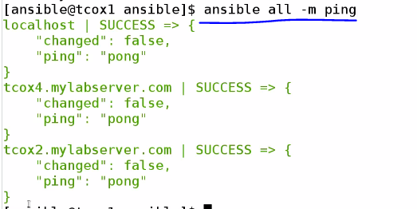

-m for define module



-a for any arbitrary command

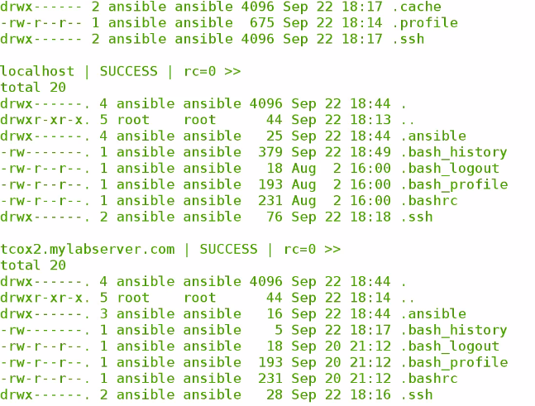

Failed becoz permission denied ,because only root have access that file

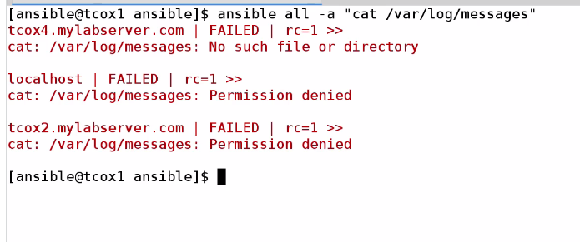

As we need to use sudo previlege like that

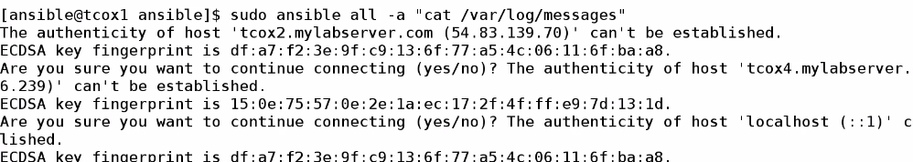

Again getting error we didn’t exchange key for root user

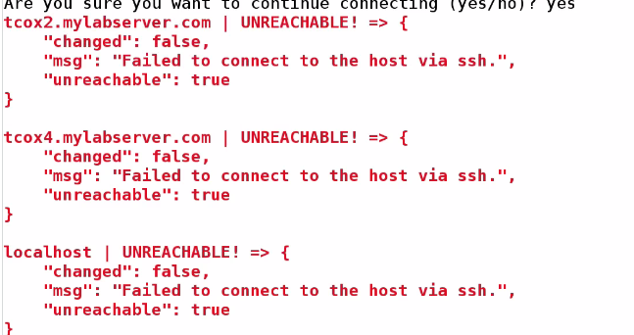

So the right way is

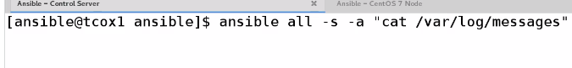

As we given ansible user sudo previlege with no passwd option .

We van use all kind of module

Example :

Using module copy

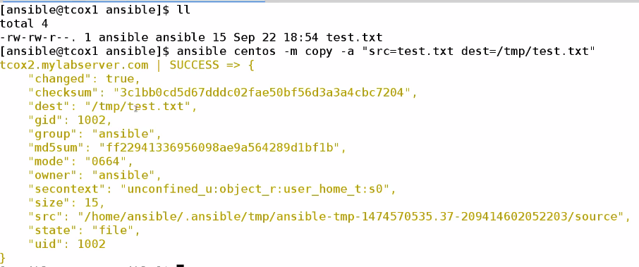

Installing packeage in ubuntu

For removing

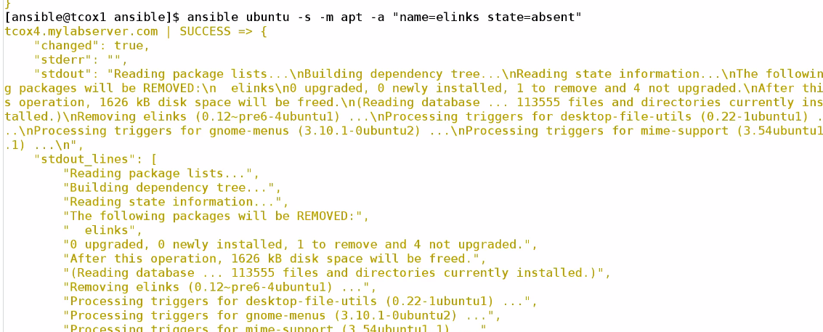

For installing ,

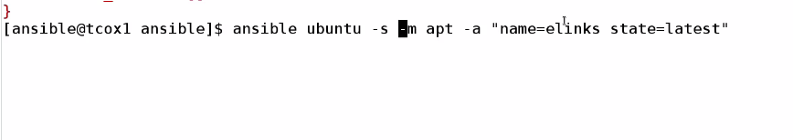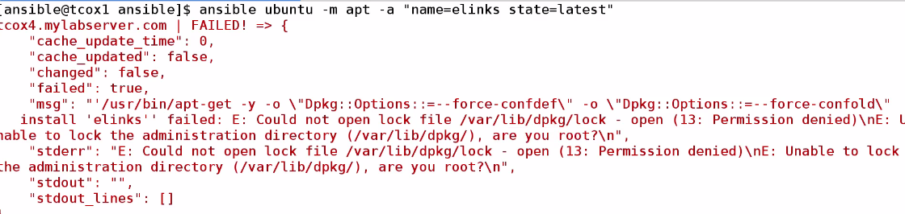

We could se failed without sudo

Create user :

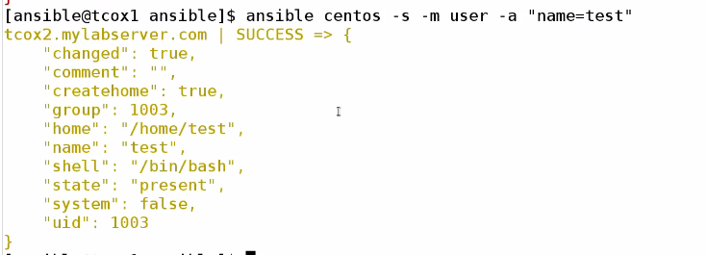

For removing

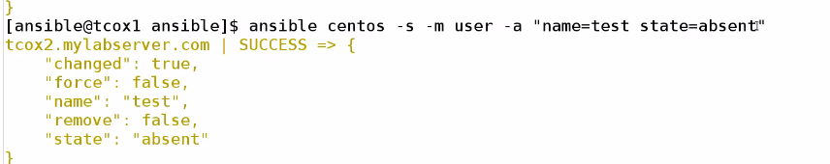

Conclusion :

asnsible host_name/group -a(for arbitrary command) / -m (for module)

